Data analysis of used car database
Data Analysis or sometimes referred to as exploratory data analysis (EDA) is one of the core components of data science. This repository demonstrates some common exploratory data analysis methods and techniques using python.

Dataset Overview
- The dataset contains details of the used cars in Germany which are on sale on eBay.
- The dataset is not clean and hence a lot of data cleaning is carried out. For e.g. prices were too high which are replaced by the median and outliers are removed accordingly.
- The dataset is cleaned and stored in a Datapreparation folder which contains the entire cleaned dataset named as cleaned_autos. another folder named cleaned_autos_analysis containing files structures containing subsets of the cleaned dataset.

Sample Dataset
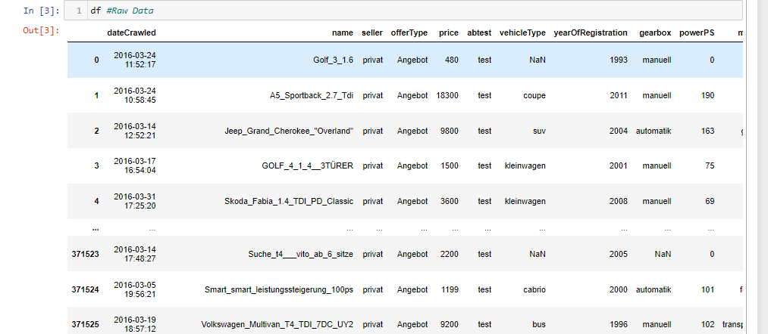

Analysis 1
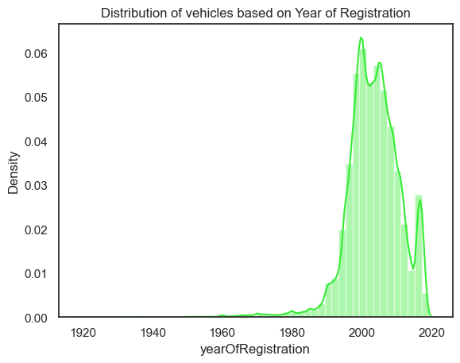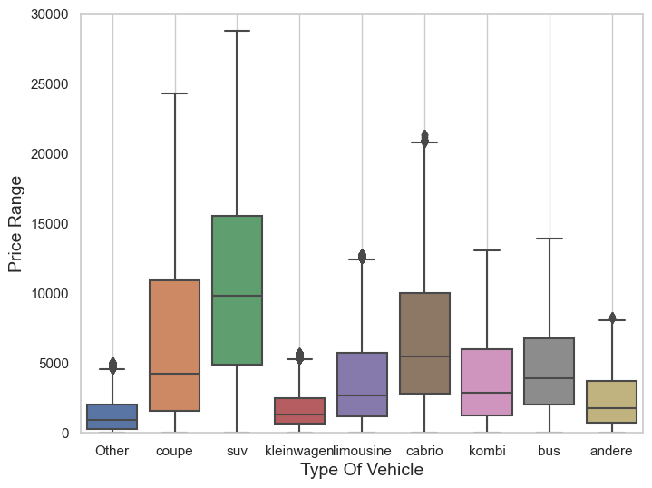

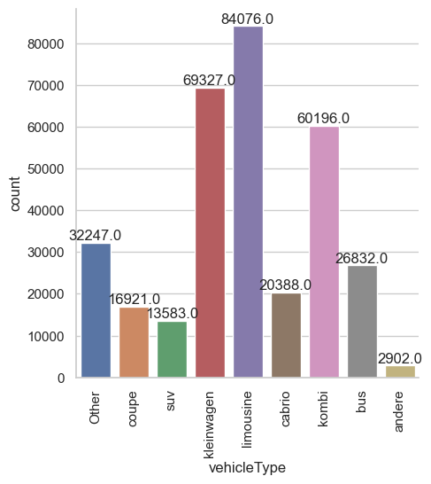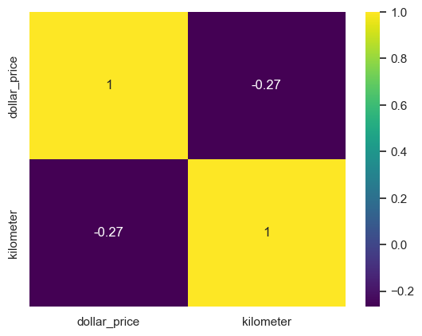

- This analysis gives the distribution of vehicles based on year of Registration and prices of vehicles based on vehicles types

- From the plot above we can see that the surge of cars is from the years 1990 to 2010.
- Overall, the visualization shows that the number of vehicles registered has increased steadily over period of time and that the fleet of vehicles on the road is relatively young.

- The median value of an SUV is 10,000, with most values between 5000 and 15000.
- The slight negative correlation suggests that mileage is an important factor to consider when pricing a used car.

Analysis 2

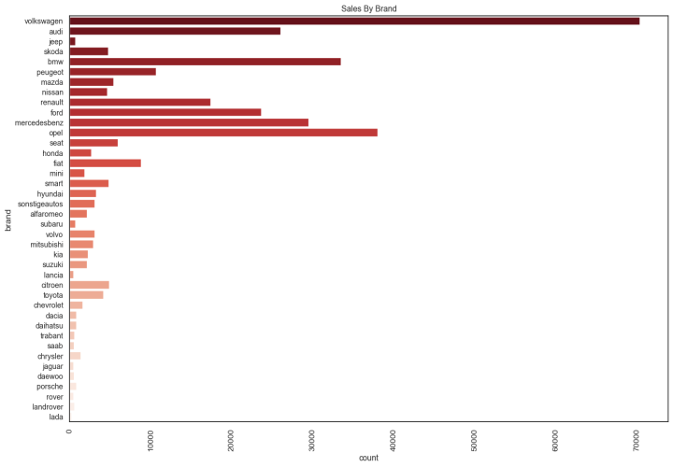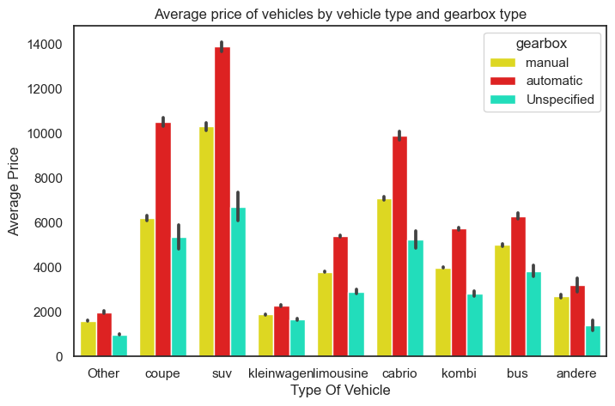

- This analysis gives the number of cars which are available for sale in the entire dataset based on a particular brand.
- As we can see the brand “Volkswagen” has the highest count as compared to other brands.
- We can see that the “SUV” type of vehicle shows the highest average price which has the gearbox type “automatic” compare to manual.
- SUV type of vehicles with gearbox type automatic has the maximum power and kleinwagen with the least.

Analysis 3
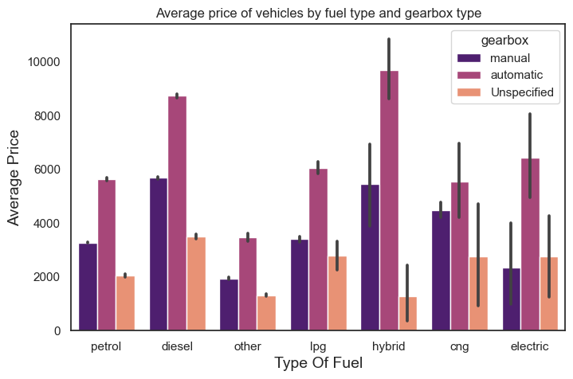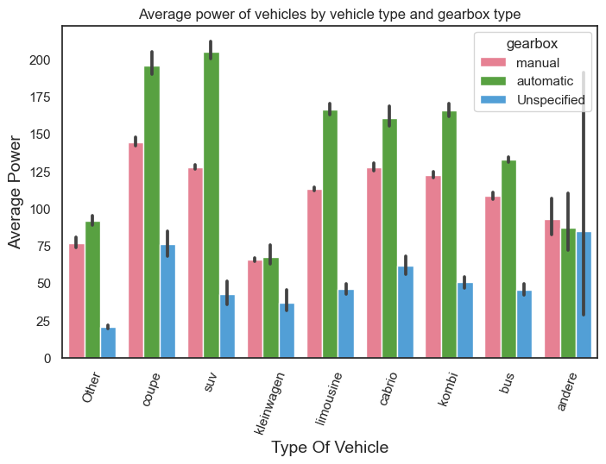

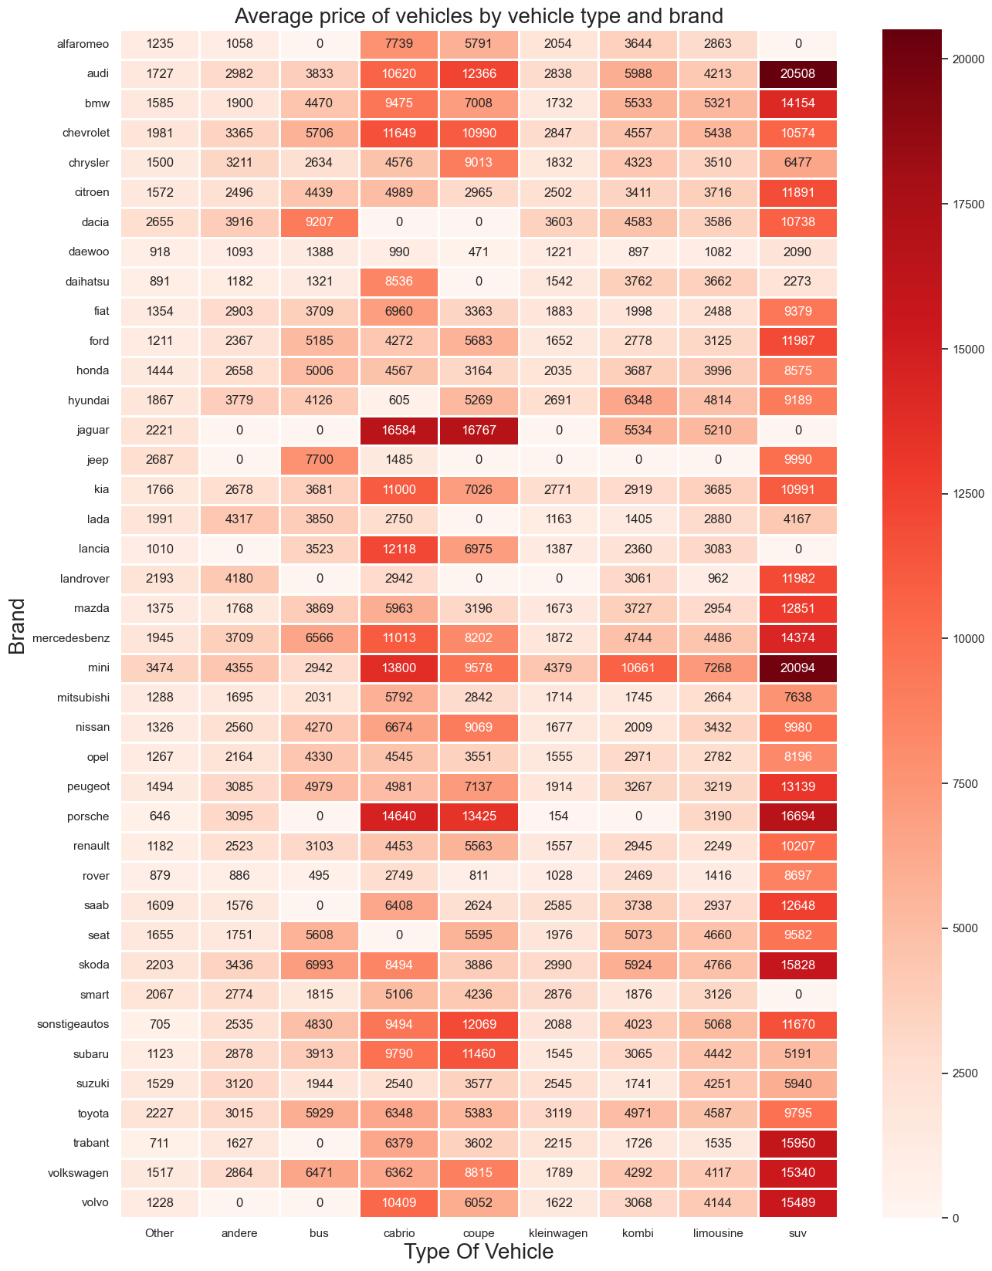
- Average price of vehicles that are Hybrid are most expensive as compared to other fuel types like Diesel and Gasoline
- The automatic SUVs cars have the higher average power and kleinwagen is the least among all the vehicle type.
- This analysis gives you the average price of the brand of vehicles and their types which are likely to be found in the dataset.
- Vehicles of brand Audi and type SUV are the most expensive of the available vehicles for sale.
- Vehicles of brand Porsche and type kleinwagen are the least expensive of the available vehicles for sale.

